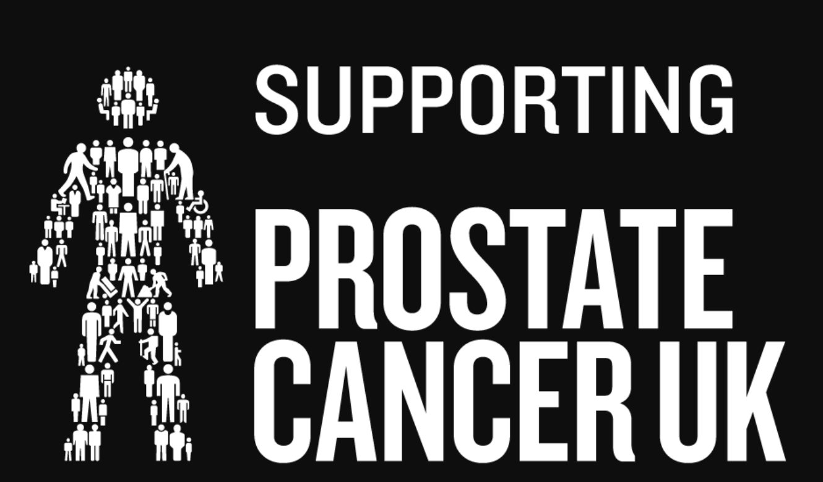Prostate Cancer Day Open Competition
1ST July 2020
Team ladies and gents Stapleford Am Am competition
ENTRY FORM
CLOSING DATE: June 1st 2020

We are hoping to raise money for the Prostate Cancer charity to help with research and to help those struggling with the illness. Brian Howard, our father, loyal Captain, President, and long serving club secretary of North Shore died in 2017 of prostate Cancer.

The competition will be a team Stapleford competition for gents and ladies teams and mixed teams.

Prizes will be for 1st – 5th place teams and the 1st all ladies team. The fee will also include a meal. Opportunities to win in a raffle and to place bids on items that will be auctioned
These include items such as:
- Laura Davis sign Glove
- A Seve Ballesteros signed club
- A pair of Anthony Joshua boxing Gloves.

If you wish to enter please return clearly marked “Prostate Cancer Day” Competitions Secretary, North Shore G.C. North Shore Road, Skegness, Lincs. PE25 1DN. (Including S.A.E for Tee Times or email address)

Name: _________________________________________________________________________
Address: _________________________________________________________________________

Tel: ___________________ Email Address: ____________________________________

The above named will be notified of all starting times on behalf of persons below. All players must have up to date CONGU handicaps. Handicap Limits Men 28. Ladies 36 .90% Allowance

Website: www.northshorehotel.co.uk
Email: secretarynsgc@gmail.com

PLEASE MAKE CHEQUES PAYABLE TO NORTH SHORE GOLF CLUB.
TOTAL: £140.00 (includes meal)

Team Name: _______________________________________________________________

 | NAMES | CDH No | PREF TIME | FEE
A
B
C
D

